EXAMENUL DE BACALAUREAT – 2012
Proba E.d)
Proba scrisă la CHIMIE ORGANICĂ (Nivel I/ Nivel II)

BAREM DE REZOLVARE

Subiectul I (30 puncte)

Subiectul A

- nepolare
- cetona
- clorură de tertbutil
- etanoat de metil
- C-H ……..................................................…….…….2p x 5 = 10 puncte

Subiectul B

- d
- b
- a
- c
- c ..................................................................................………….…….2p x 5 = 10 puncte

Subiectul C

- Grupe fractionale: carboxil (-COOH)
hidroxil alcool (-OH) 1p x 2 = 2 puncte

- Formula moleculară (A) C₄H₆O₆
M_{A} = 150g/mol
%O = 100
%O = 100 = 48 ..................................................………….……………….2 puncte

- C₁ si C₂: secundari ...........................................................………….…….1p x 2= 2 puncte

- (A) + 2NaOH (aq) COO ⁻ Na⁺
CH – OH
+2H₂O
CH – OH
COO ⁻ Na⁺ ………….…...............................…………….2 puncte

- 1 mol (A) ……….. 2 moli NaOH ……….. 1 mol produs
mC₄H₄O₆Na₂ = n M; M_{produs}= 194g/mol
mC₄H₄O₆Na₂ = 194 g……….....................................………….……………….2 puncte

Subiectul D

- a. CH₄(g) + 2O₂(g) CO₂(g) + 2H₂O(g) + Q ..........………….……………….2 puncte

b. 1000L CH₄…………….. 8550 kcal
100 x 22,4L CH₄……… Q
Q = 19152 kcal .............................………….……………….3 puncte
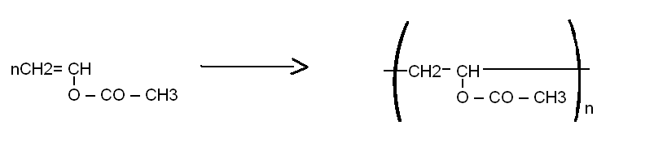

......2 puncte

- a. M_{polimer =} n M_{monomer}
M_{monomer} = 86g/mol
129000 = n 86
n = 1500 .....................................................................………….……………….2 puncte

b. Poliacetatul de vinil este utilizat la obtinerea de mase plastice......……..……….1 punct

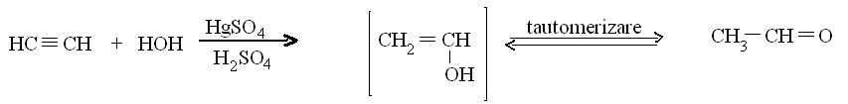

.......................................2 puncte

- nC₂H₂= = = 25 kmoli
25 kmoli C₂H₂…………………… 25 kmoli C₂H₄O la η = 100%;
η = 100 => m_{p =} 25 = 20 kmoli C₂H₄O
M C₂H₄O = n M = 20 44 = 880 kg la η = 80%;..........………….……………….3 puncte

Subiectul E

1. a. CH₃ − CH₂ − OH + [O] $\frac{K_{2}{\text{Cr}}_{2}O_{7}}{H_{3}O^{+}}$ CH₃ − CH ‏═O +H₂O ............................2 puncte

b. ρ = $\frac{m}{V}$ => m_{bere} = 500 mL · 1,15 g/ml = 575 g ..........................................................1 punct

m${}_{C_{2}H_{5}\text{OH}}$ = $\frac{4}{\text{100}}⋅$M_{bere}

m${}_{C_{2}H_{5}\text{OH}}$ = $\frac{4}{\text{100}}⋅$575 = 23 g ........................................................................................1 punct

m${}_{C_{2}H_{5}\text{OH}}$ = $\frac{m}{M}$ = $\frac{\text{23}}{\text{46}}$= 0,5 moli

Din ecuatie : 0,5 moli C₂H₅OH ................0,5 moli C₂H₄O

M C₂H₄O = n · M = 0,5 · 44 = 22g ........................................................................................1 punct

2.
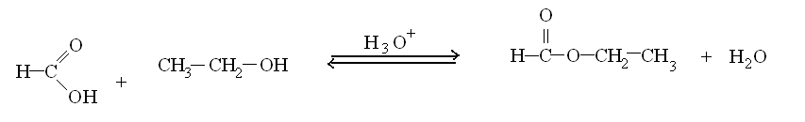
.................................................................................2 puncte

3. n _{HCOOH} = $\frac{\text{20},7}{\text{46}}$ = 0,45 moli

0,45 moli HCOOH ...........................0,45 moli C₃H₆O₂ la η = 100% ...............................1 punct

η = $\frac{n_{p}}{n_{t}}$ => n_{p} = $\frac{\text{70}}{\text{100}}⋅0,\text{45}$ = 0,315 moli C₃H₆O₂ la η = 70% ..................................1 punct

m C3H6O2 = n · M = 0,315 · 74 = 23,31 g ...........................................................................1 punct

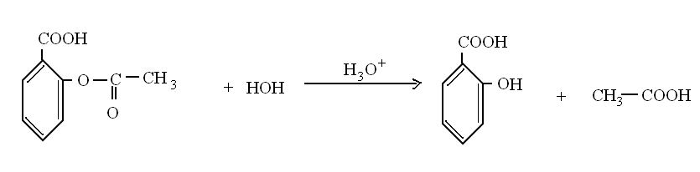
4.

.....................................................................2 puncte

5. m _{C9H8O4} din 20 comprimate = 20 · 0,45 = 9g ................................................................1 punct

Din ecuatia:

M_{C9H8O4} ................................................. M_{C7H6O3}
180 g C₉H₈O₄ ....................................138 g C₇H₆O₃
9 g C₉H₈O₄ .................................... x

X= 6,9 g C₇H₆O₃ (acid salicilic) ..............................2 puncte

Subiectul al III-lea (30 puncte)

Subiectul F
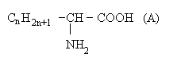
1.a. Formula generala a unui aminoacid monoaminomonocarboxilic

Formula dipeptidei dintre valina si aminoacidul (A):
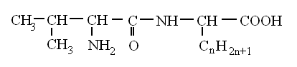

14n +174 = 174 = > n=0 => formula moleculara (A) : C₂H₅O₂N ..................3 puncte

b. Denumire I.U.P.A.C. a aminoacidului (A) : acid aminoetanoic ....................................1 punct

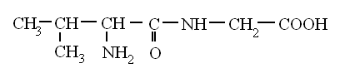
Formula structurala a valil- glicinei

........................................2 puncte
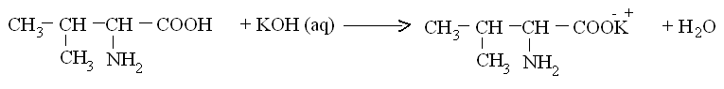
2. ......................................................2 puncte
3. 0,3moli C₅H₁₁NO₂ ....................................... 0,3 moli KOH

C_{M} = $\frac{n}{\text{Vs}}$ => V solutie KOH = $\frac{n}{C_{M}}$ => V solutie KOH = $\frac{0,3}{2}$= 0,15 L = 150mL ....3 puncte

4. Formula aciclica glucozei
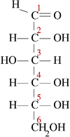

………….……………….2 puncte
- La tratarea cu solutie de iod, amidonul se coloreaza in albastru ………........…….2 puncte

Subiectul G1 ( Obligatoriu pentru nivel I )

1. Forma generala a unei arene mononucleare (A):
C_{n}H_{2n – 6}

14n - 6 = 120 => n = 9 => formula moleculară (A): C₉H₁₂ ……….……………….2 puncte

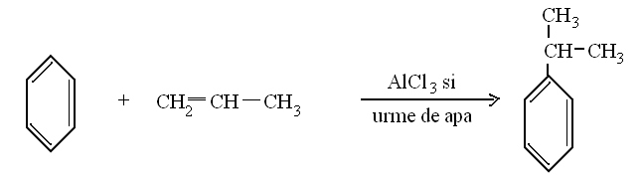
2. a.
………….……………….2 puncte

b. Denumirea alchenei: propena ...................................………….…..…………....….1 punct
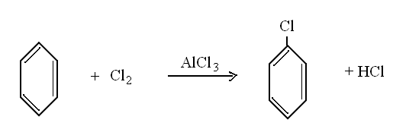
3. a.

.....................................................2 puncte

b) n _{C6H5Cl} =$\frac{m}{M}$ = $\frac{\text{900}}{\text{112},5}$ = 8 moli
8 moli C₆H₅Cl .............. 8 moli C₆H₆
m C₆H₆ = n M = 8 78 = 624 g (puritate 100%) ………….…....………....…….2 puncte

p% = $\frac{m_{\text{pura}}}{m_{\text{impura}}}⋅$100 => m _{impura C6H6} = $\frac{\text{624}⋅\text{100}}{\text{90}}$ = 693,33 g (puritate 90%)……....1 punct
4. 8 moli C₆H₆ .............. 8 moli Cl₂
PV = nRT => V Cl₂ = $\frac{\text{nRT}}{P}$ =>
V Cl₂ = $\frac{8\text{moli}⋅0,\text{082}L⋅\text{atm}⋅(\text{273}+\text{27})k}{k⋅\text{mol}⋅2\text{atm}}$ => V_{Cl2} = 98,4…….......….3 puncte
5. Formula moleculara toluen : C₇H₈
m C : m H = (7 12) : 8 = 84 : 8 = 21 : 2 ………….……….........................……….2 puncte

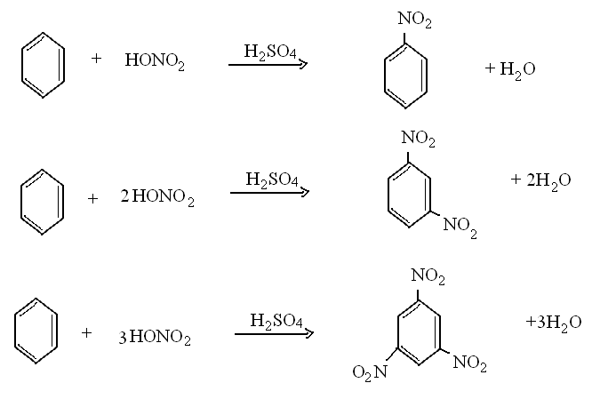
Subiectul G2 ( Obligatoriu pentru nivel II )

1.

….........…..….3 ecuatii x 2 puncte = 6 puncte

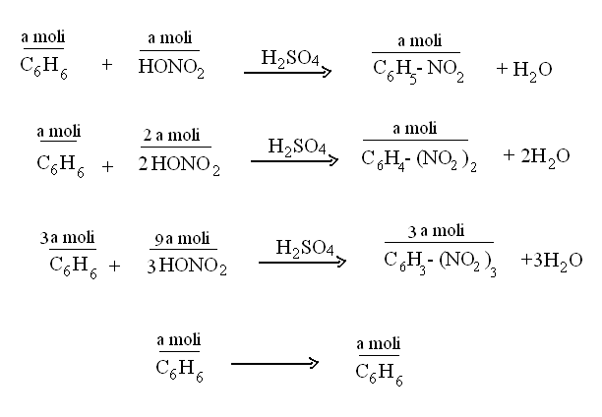
2.

Conversia totala = $\frac{{\text{nC}}_{6}H_{6}\text{transformat}}{{\text{nC}}_{6}H_{6}\text{total}}⋅$ 100

C_{t} = 100 = > C_{C6H6} = 83,33% ………………………………………......……….3 puncte

- 6a = n C₆H₆
6a = => a = 2
n _{HNO3} = 12a
n _{HNO3} = 12 . 2 = 24 moli
m _{HNO3} = 24 . M = 24 .63 = 1512 g ( m_{d} )
c = 100 => m_{solutie HNO3} = $\frac{m_{d}⋅\text{100}}{c}$= $\frac{\text{1512}⋅\text{100}}{\text{60}}$= 2520 g ...…………...........3 puncte

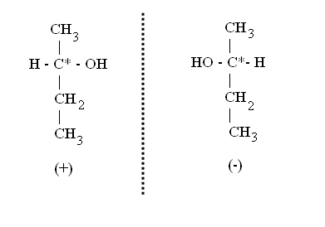
4.

………….……….2 puncte

5. Amestecul echimolar de enantiomeri dextronir si levogir al 2-butanolului este optic inactiv si se numeste racenic.................................................................. .………….……….……….1 punct

